**Welcome to Day #5 of CGCC!**

Every day we will have a GitHub repository page that outlines each day and the activities that we will complete. We will also provide all homework on these pages.

Feel free to browse the other days to see what is coming up!

As always, let us know if you need any help or have any questions.

**Day 5: UI and More Prototyping!**

**Day 5 Playlist:** https://www.youtube.com/playlist?list=PLjuJhbLl_2nvYhi_1ioaUFKy2A8c3QQqY

**SCHEDULE:**

* Instructors start the video call.
* What is UI Design? (~10 minutes) **[Camp]**
* Identify important UI elements (5 minutes) **[Group]**
* PracticeGoDot UI development (50 min) **[Individual -> guided lecture]**
* **10 minute break**
* Brainstorm the UI for your game (15 min) **[group]**
* What is prototyping? (approximately 10 minutes) **[camp]**
* Summarize with a prototype video (7.5 minutes) **[camp]**
* Prototype the UI for your game (50 min) **[individual -> within group]**

**Total time: ~152.5 minutes.**

**INSTRUCTION:** What is UI Design? (~10 minutes) **[Camp]**

* User Interface, or UI, is what the user interacts with in order to use an online/digital service, program, application, etc.
* Have everyone pull up a game called cookie clicker. ( <https://orteil.dashnet.org/cookieclicker/> )
* What are the elements cookie clicker’s UI? Some examples:
  + Counter for number of cookies.
  + Store for upgrades.
  + Separate tabs for stats, options, and about information.
  + Easy to access achievements section.
* Discuss what the goal of Cookie Clicker’s UI is:
  + Keep players playing the game.
  + Make the website pleasant to look at.
* Some UI design principals from Adobe: (https://xd.adobe.com/ideas/process/ui-design/4-golden-rules-ui-design/)
  + **Place users in control of the interface**
    - Visual cues
    - Predictability
    - Make actions reversable
  + **Make it comfortable to interact with a product**
    - Eliminate all elements that are not helping your users
    - Design accessible interfaces
    - Engineer for errors
  + **Reduce cognitive load**
    - Reduce the number of actions required to complete a task
    - Promote visual clarity
  + **Make user interfaces consistent**
    - Visual consistency
    - Functional consistency
* Keeping those principals in mind, let’s look back at cookie clicker. What are some things that cookie clicker does that fall in line with these principals?

**ACTIVITY:** Identify important UI elements (5 minutes) **[Group]**

* Blitz through some of these images and as a camp point out the first 3 elements in each picture that grabs your attention first.

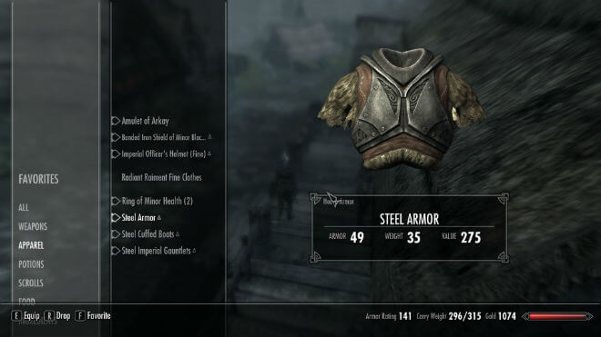

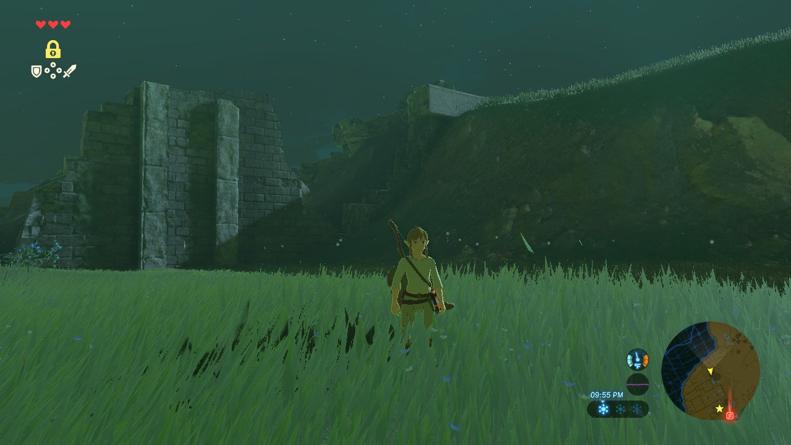

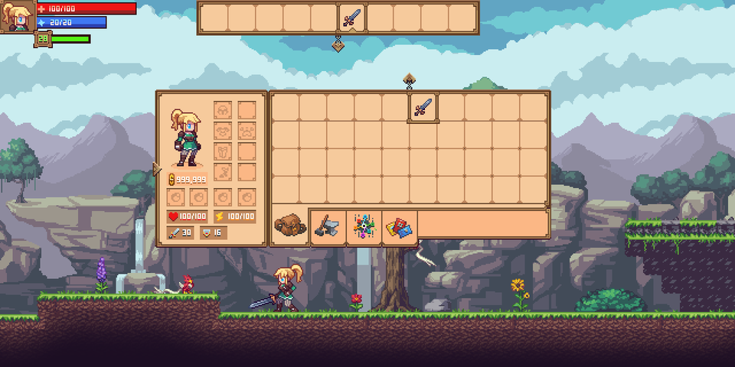

* Reflect: Was there any patterns in the elements that were always spotted first?
  + Ex: elements in the top right of the picture were spotted first.
  + Ex: health indicators were spotted first.
* Reflect: Were there any pattern in elements that the different games shared? Do you think that was intentional in any way?
  + Ex: Location of health indicators.

**ACTIVITY:** PracticeGoDot UI development (50 min) **[Individual -> guided lecture]**

* Now we are going to practice working with UI in GoDot using the ideas and themes we’ve been talking about today.
* Go into GoDot and open up the Asteroids game that you worked with yesterday.
* We need to give this game some UI elements to make the experience more enjoyable.
* Here’s a list of things we want to consider adding:
  + Start button
  + Asteroid count
  + Ship health
* We’ll start with the life counter and score.
* Start by creating a new scene with a 2D *CanvasLayer* node.
* Inside the canvas layer, add a *MarginContainer* child node. The MarginContainer will help with the padding around our score and life count.
* Once we have our MarginContainer, we need to do two different things:
  + First, open the layout menu right under the “2D” option near the top of your screen and select “Top Wide”. Then in the inspector, open the “Custom Constants” menu and set all the margins to 20.

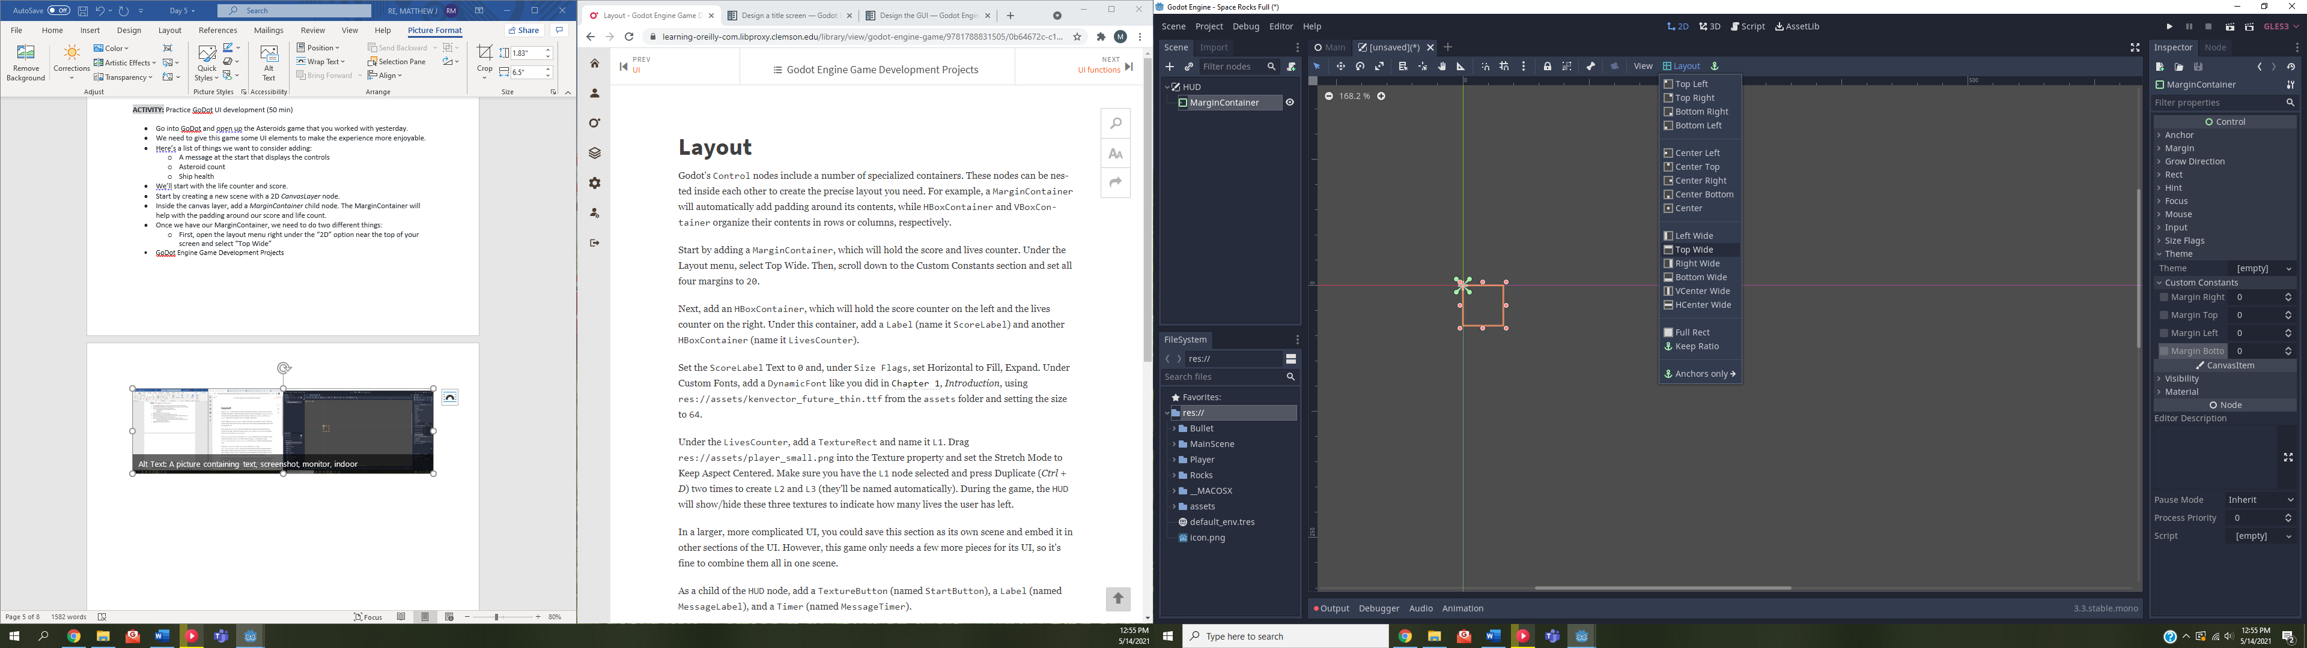 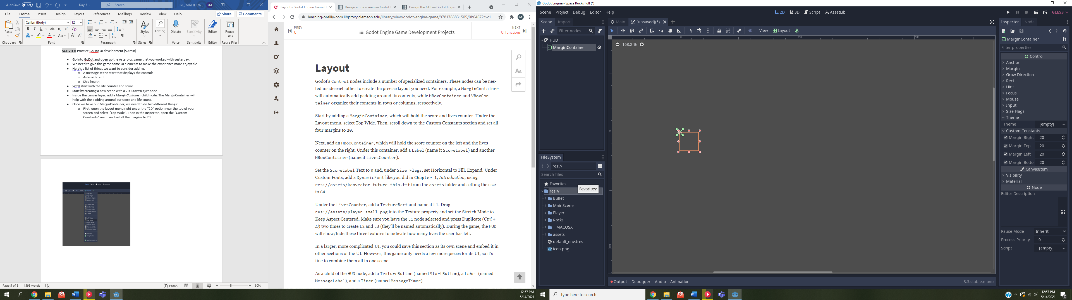

* Next, add an *HBoxContainer,* which is the node that will actually be storing our score and lives, as a child of the MarginContainer.
  + The HBoxContainer should have 2 child nodes, a label for the score and another HBoxContainer for the lives.
  + Feel free to start naming your nodes so it’s easier to tell what does what. I’ll choose to name my label “ScoreLabel” and my 2nd HBoxContainer “LivesCounter”.
  + Our Scene should look something like this by this point:
  + 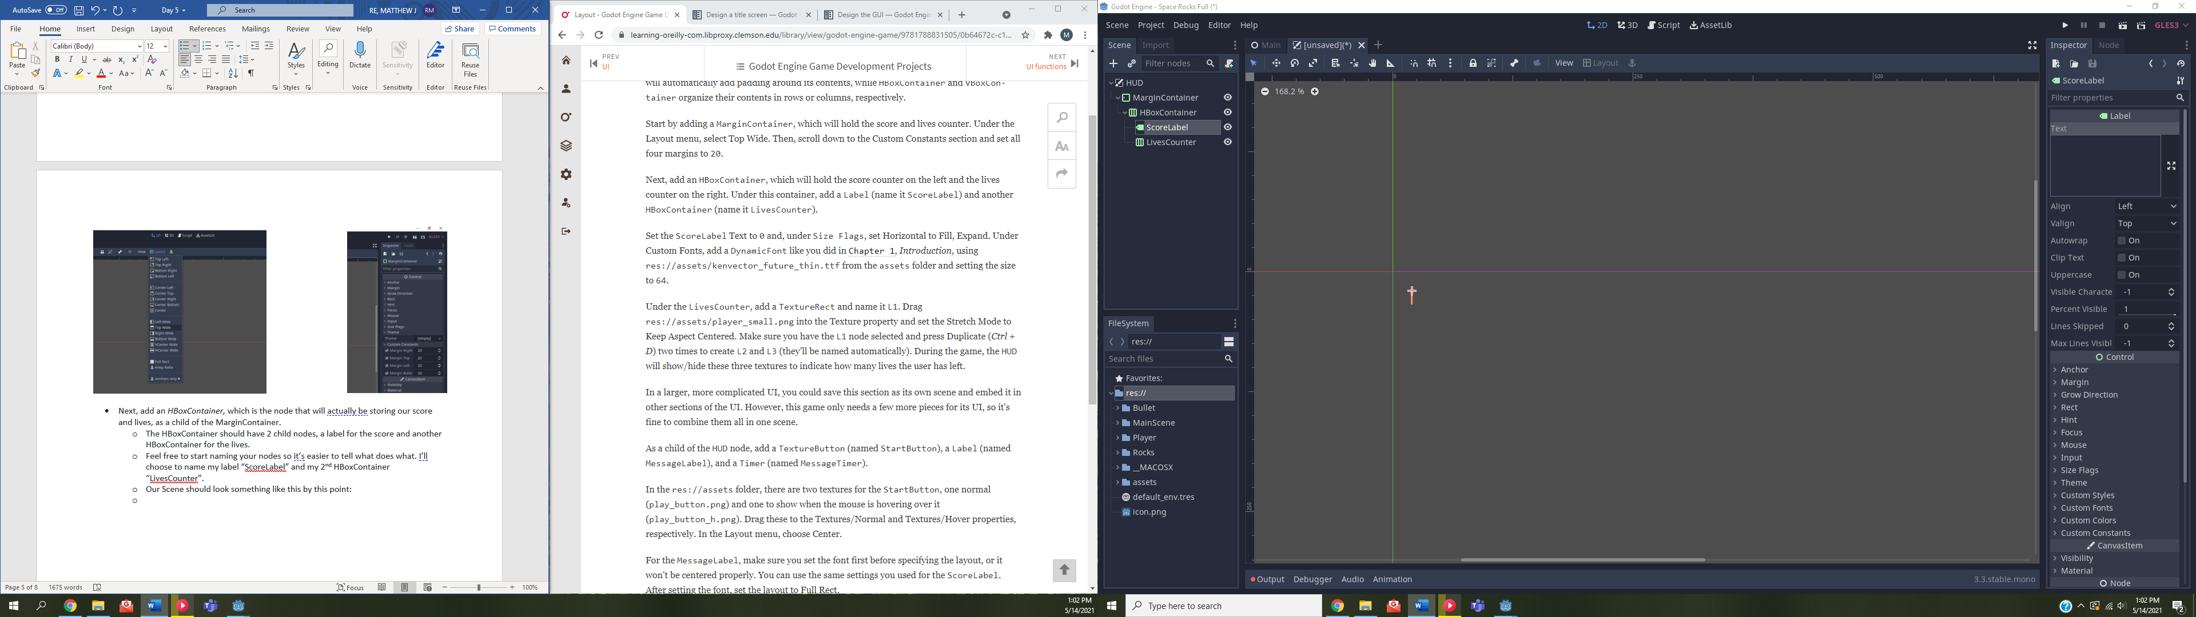
* ANY QUESTIONS SO FAR? ANYONE STUCK?
* Now, let’s set up our label
  + In the ScoreLabel, go ahead in the inspector and set the text to “0”.
  + Down a bit, open up the Size Flags tab and set the Horizontal to “Fill” and “Expand”
  + In the File System dock window, search for “ken”. You should see two different files appear. The one we want is “kenvector_future_thin.ttf”.
  + Back in the inspector, open the “Custom Fonts” tab. Click on the box that says [empty] and add a “New DynamicFont”.
  + Click on the same box (now it says DynamicFont instead of empty) and click the Font tab.
  + From the File System, drag the “kenvector_future_thin.ttf” to the Font Data in the inspector.
  + Then, also in the inspector, open up the settings and set the size of the font to 64.
* Now, let’s set up the 2nd HBoxContainer we called LivesCounter
  + In the Scene dock window, we need to add a *TextureRect* as a child node. This will be where we keep the image for our lives.
  + In your file system, search for “player_small”. Two might appear, but we want the one that isn’t a red X. Drag the correct player_small to the Texture field of inspector. While we’re here, we can also set the Stretch mode to “keep aspect centered”.
  + Our game will have three lives, so instead of just repeating those steps, in the Scene dock window, be sure your TextureRect is selected and duplicate it twice to create 3 total TextureRects.
  + Rename each TextureRect to L1, L2, and L3.
* ANY QUESTIONS SO FAR? ANYONE STUCK?
* Now, we’re going to add 3 more children to the HUD node.
* We’re going to need a *TextureButton, Label,* and a *Timer.*
  + Rename these three children as “StartButton”, “MessageLabel”, and “MessageTimer”.
* In the inspector for the StartButton, open up the Textures menu and locate the play_button PNGs in the file system.
  + Again, some red X assets might appear, ignore those. For now, drag the “play_button.png” to the Normal texture field in the inspector, and the “play_button_h.png” to the Hover texture field.
  + In the layout menu, set the StartButton as “Center”
* For the MessageLabel, set the font the same way we did for the ScoreLabel.
  + Keep the message blank for now.
  + Create a new dynamic font in the Custom Font tab.
  + Set the Font Data as the “kenvector_future_thin.ttf”
  + Set the font size to 64.
  + In the layout menu, set it to any layout to Full Rect.
* Finally, for the MessageTimer, go into the inspector and set the One Shot property to “On” (check the box) and set the Wait Time from 1 to 2.
* Our UI so far should look something like this:

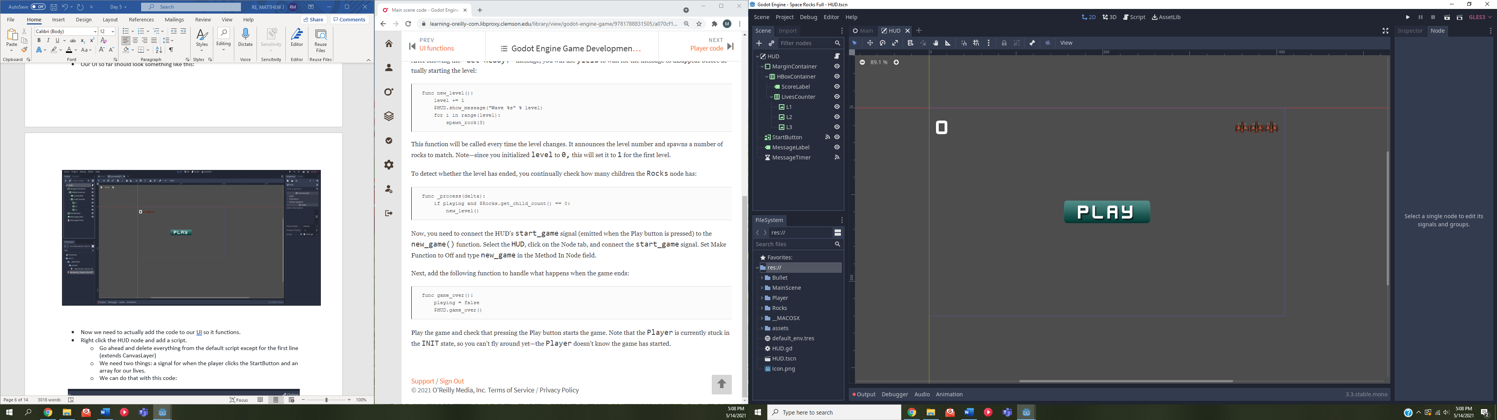

* Now we need to actually add the code to our UI so it functions.
* Right click the HUD node and add a script.
  + Go ahead and delete everything from the default script except for the first line (extends CanvasLayer)
  + We need two things: a signal for when the player clicks the StartButton and an array for our lives.
  + We can do that with this code:

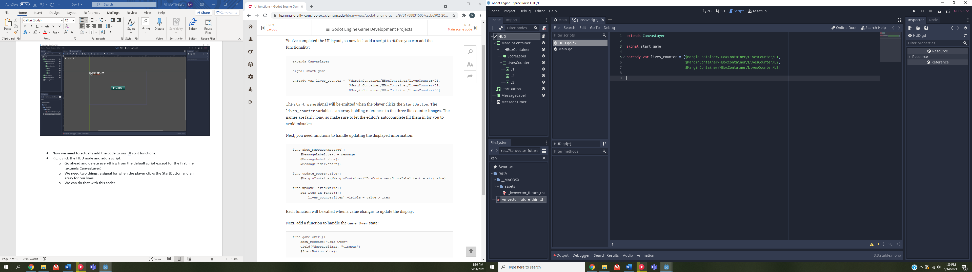

* Now we need a few functions/methods for updating what is being displayed though out HUD to the player. We’ll need a function for show_message, update_score, and update_lives.
* Starting with the show_message function, our function will need to take a message as a parameter since we don’t have the message we want to display as a variable at the time of writing the function
  + Once we have our function defined, it should do 3 things: set the incoming message as the text for the MessageLabel, show that message, and then start the message timer. The code is as simple as it sounds.

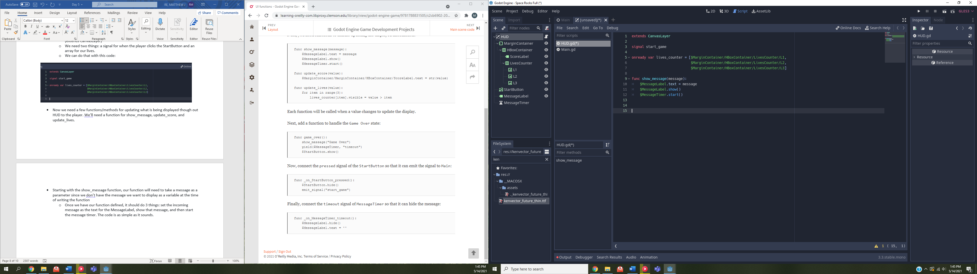

* Now we’ll write our update_score function. Again, this function will need to take a *value* as a parameter since we don’t know what the value should be at the time of creating the function.
  + Once our function Is defined, we just need to set the ScoreLabel’s text to the value that gets passed in. we’ll want to be sure we’re converting the value, which should come in as a numerical type, to a string type to avoid any errors.

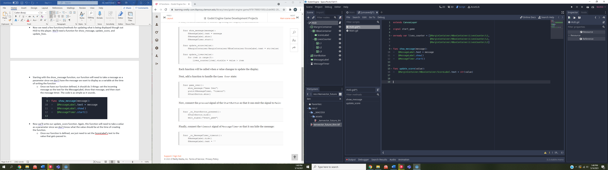

* Then for the update_lives function, you know the drill with parameters now.
  + What we’ll do is we’ll create a loop that serves to set the visibility of our three lives depending on what the value parameter is set as. For instance, if we get hit once, value will be set to 2. This will be less the index of the for loop at the third iteration (which represents the first life, or the life on the right) which causes the visibility to be set to false.

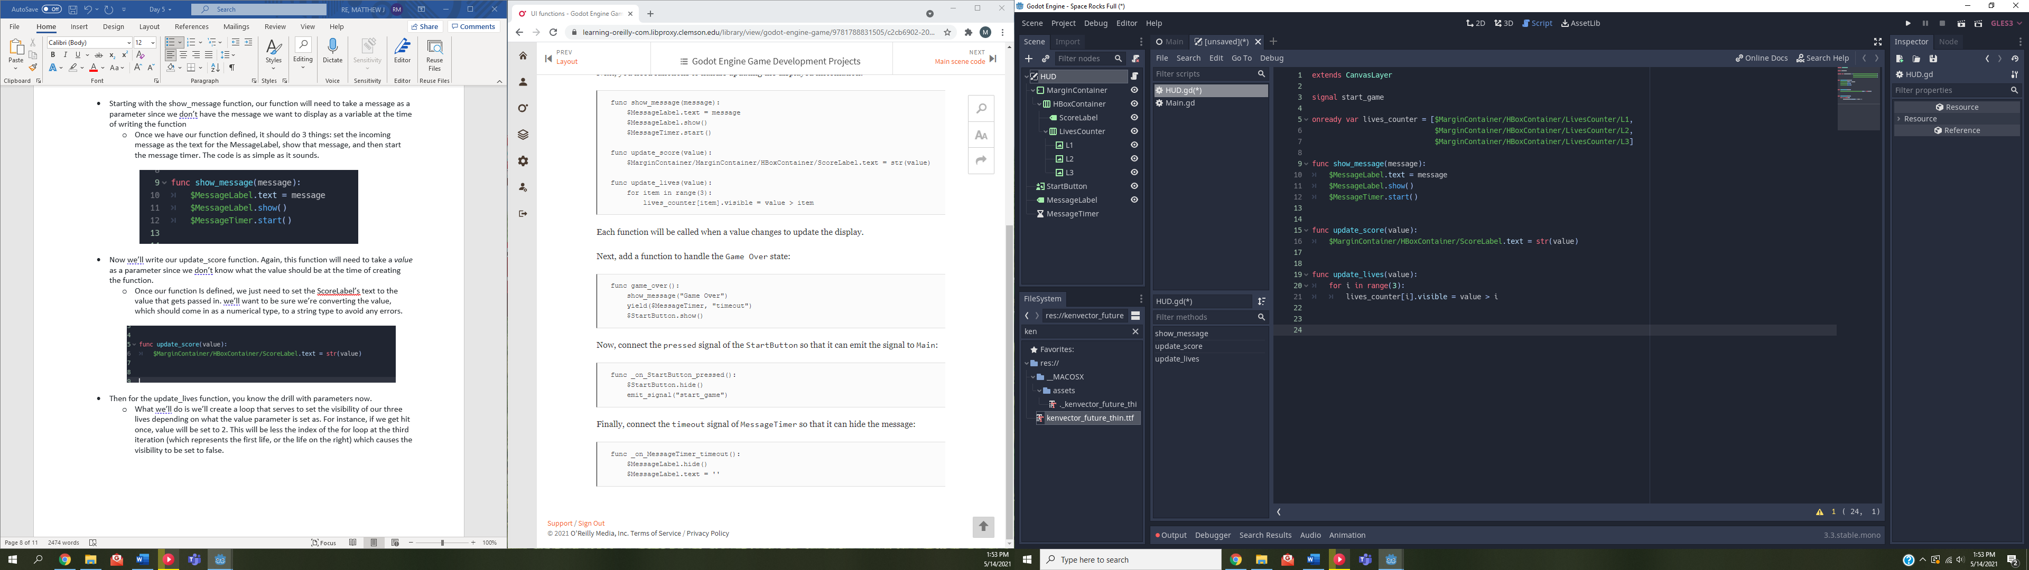

* Now we need a few more things. We need a function for game overs, a function for sending the signal to Main that the player hit the start button, and a function for hiding the message.
* For the game_over function:
  + Define your function like normal, except this time we don’t need any parameters.
  + Call our show_message function display the message “Game Over”
  + We then need to yield while we wait for the message timer to timeout.
  + Finally, we need to show the start button again.

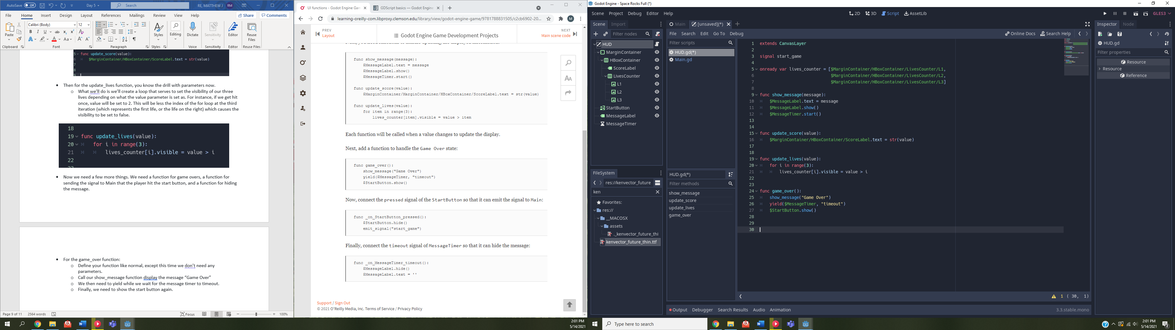

* For sending the signal to main:
  + Again, define an **_on_StartButton_pressed** function with no parameters.
  + Once it has been pressed, we want to hide the start button and emit the signal we created at the start.

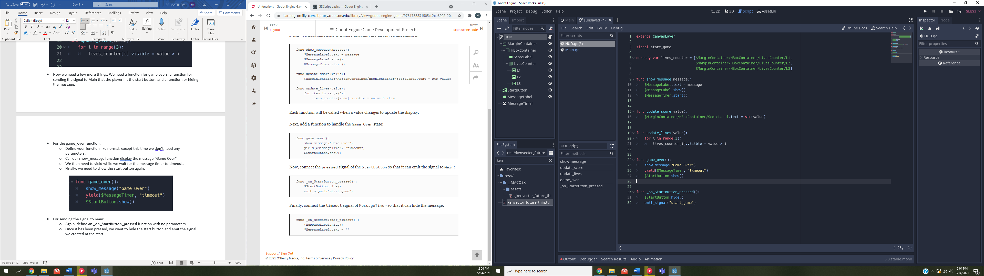

* Finally, we need the function for timing out the message timer and hiding the message:
  + Define an **_on_MessageTimer_timeout** function with no parameters.
  + Hide the MessageLabel
  + Set the MessageLabel text to nothing (“”)

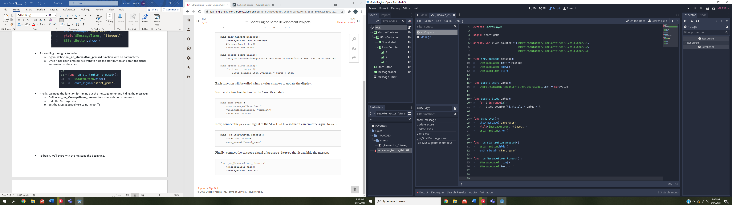

* Before we finish up the HUD, we need to connect our signals and timer.
  + On the Scene dock window, click on the StartButton and then next to the Inspector tab in the top right of the window, hit the Node tab.
  + Under “BaseButton” you should see a pressed() function. Right click it and hit connect. Hit connect again when the window pops up.
  + Do the same with the MessageTimer. In the Node tab, you should see timeout(). Again, right click and hit connect and then hit again when the window pops up. This should create “connections” with some of the functions we wrote.

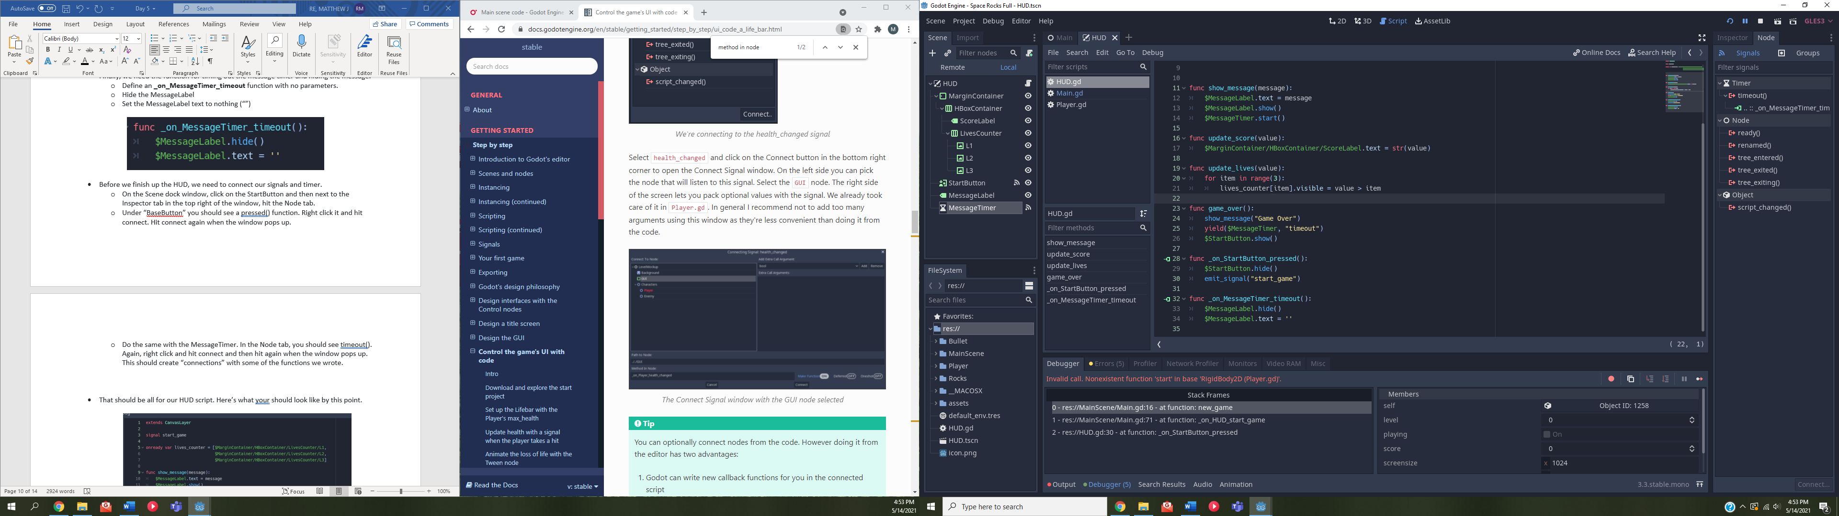

* That should be all for our HUD script. Here’s what your should look like by this point.

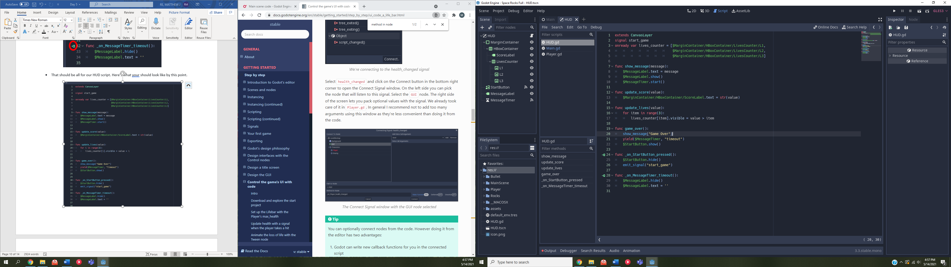

***BE SURE TO SAVE YOUR SCRIPT AND ANYTHING ELSE WE’VE DONE SO FAR***

* We need to add some things to Main scene to get everything working.
* First what we can do is add an instance of the HUD to Main.
  + Click on the Main node in the Scene dock window.
  + Click on the chain and add the HUD.tscn
* Inside our Main.gd script:
  + Create three variables, a level (set to 0), a score (set to 0), and playing (set to false).

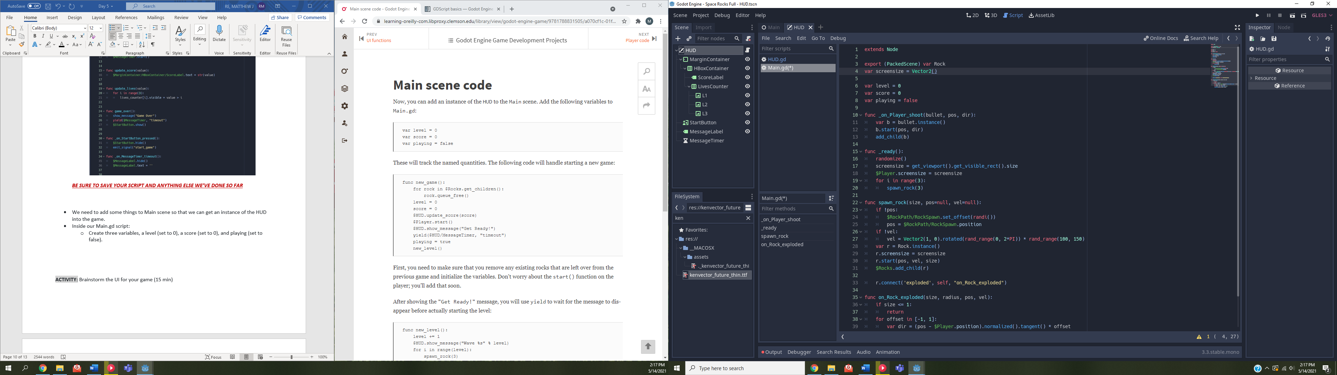

* Now we need to create a function that sets the stage for a new game
  + Define your **new_game** function
  + **For** each of your rock’s children, free the child rock’s queue
  + set level and score to 0
  + Call on the HUD and your update_score function to set the score
  + Call on the Player to **start** (We’ll write this soon)
  + Call once again on your HUD to show the “Get Ready!” message
  + Yield until that message has timed out
  + Set playing to true
  + Call **new_level** (which we’ll write in a moment)

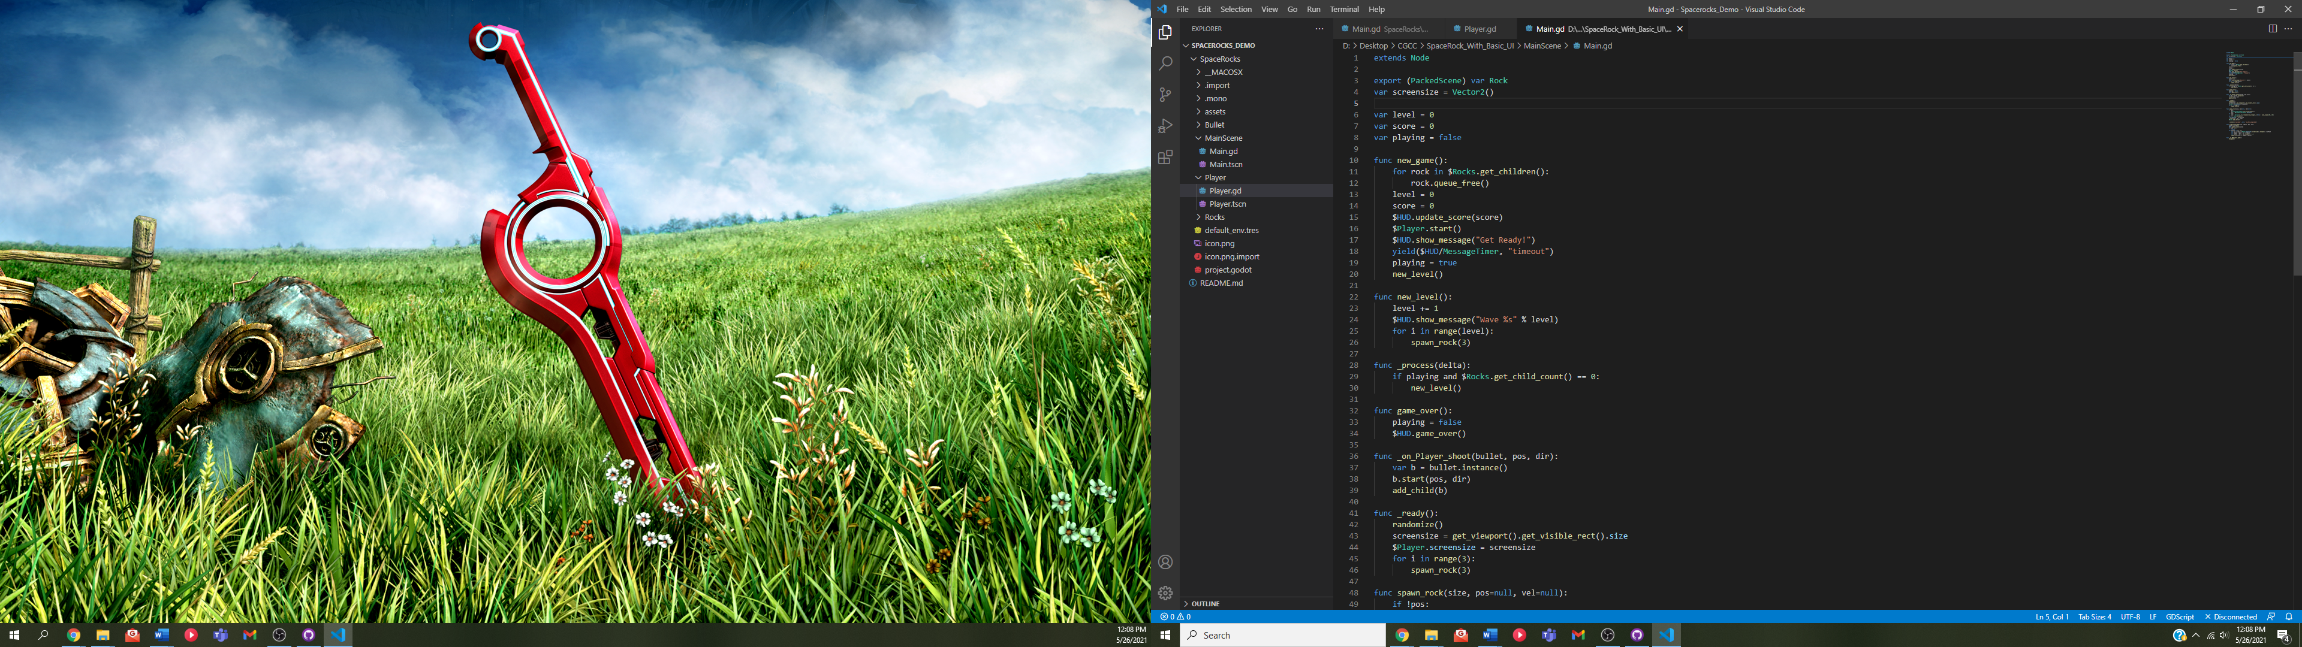

* Once all the rocks are removed and a new game is ready to go, we need to write our new level function, which will control the amount of rocks that spawn for each wave
  + Define your **new_level** function
  + Add 1 to the level variable we created at the start.
  + Call the HUD to show a message displaying the current level
  + Start spawning rocks where the number of rocks spawned is dependent on the level.

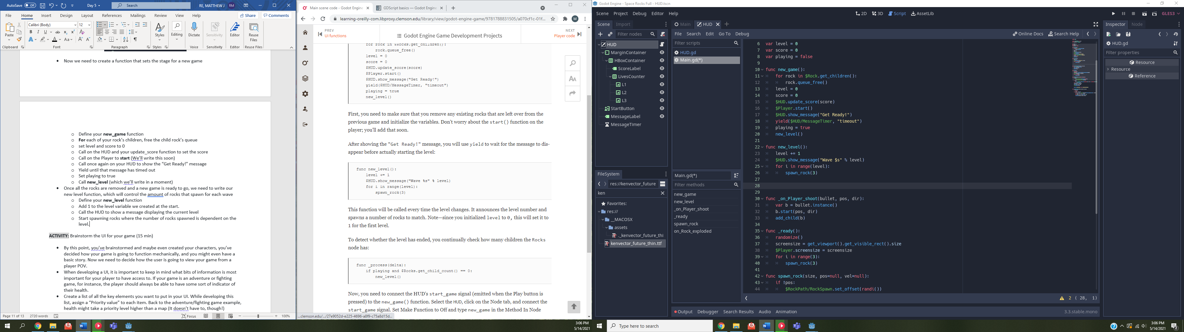

* Now with the way we have it, every time the level changes the new_level function will be called and the current level will be displayed for the player.
* However, what are we missing? We need a way to detect if the current level needs to end by checking the rock count
* We can do this by writing and calling the **_process(delta)** function, which is a function that will get called **every frame**.
  + Define the **_process(delta)** function.
  + Check if the player is playing and the rock count is 0
    - If it is, call the new_level function

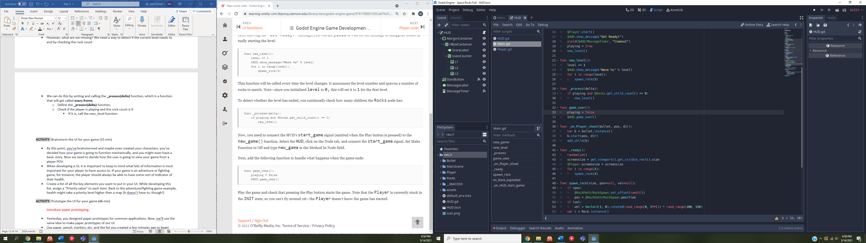

* We then need to create another connection. In the MAIN scene on the Scene dock window, click on HUD -> Node tab next to the inspector tab -> right click the start_game() -> connect -> connect.
* This will add the function **_on_HUD_start_game()**
  + Replace the body of that function with a call to your new_game function

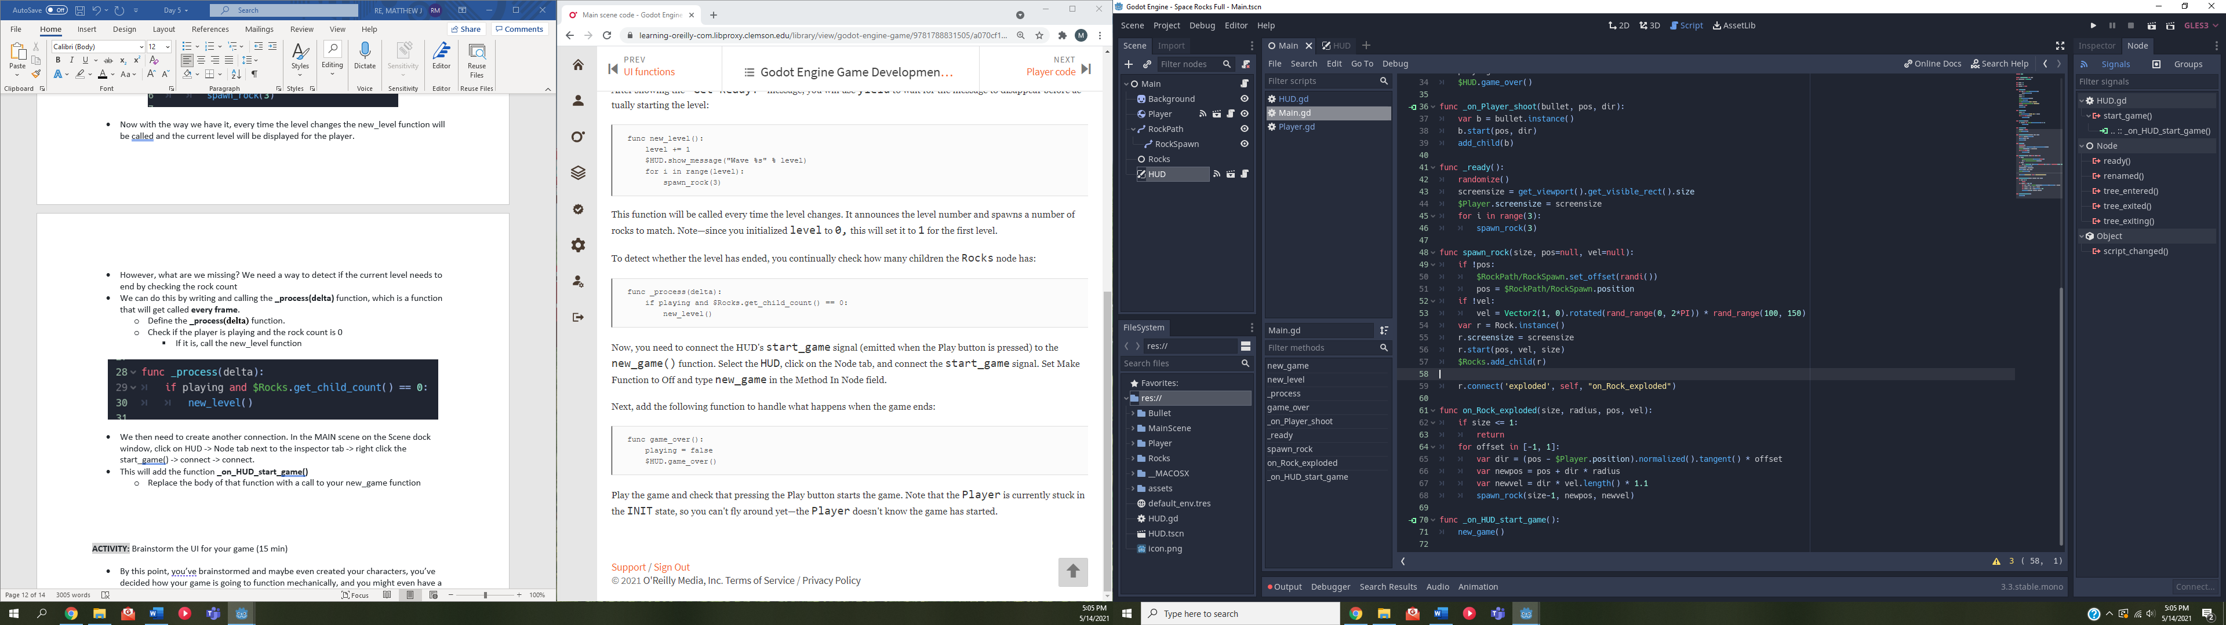

***BE SURE TO SAVE YOUR SCRIPT AND ANYTHING ELSE WE’VE DONE SO FAR***

* Now we need to update the code for the Player.
* Open up the Player.gd script and add a signal, **lives_changed**, and a variable for lives.
  + We need the variable for the lives to also call **setget**
  + **setget** will make it so when we use setget with a function after, that function will be called whenever the variable associated with it is changed.
* We need to write the function that sets the number of lives from the players perspective and then emit the signal that we declared earlier.
  + Declare your **set_lives(value)** function
  + Set the lives variable to the value in the parameter
  + And then emit the lives_changed signal with the lives variable.

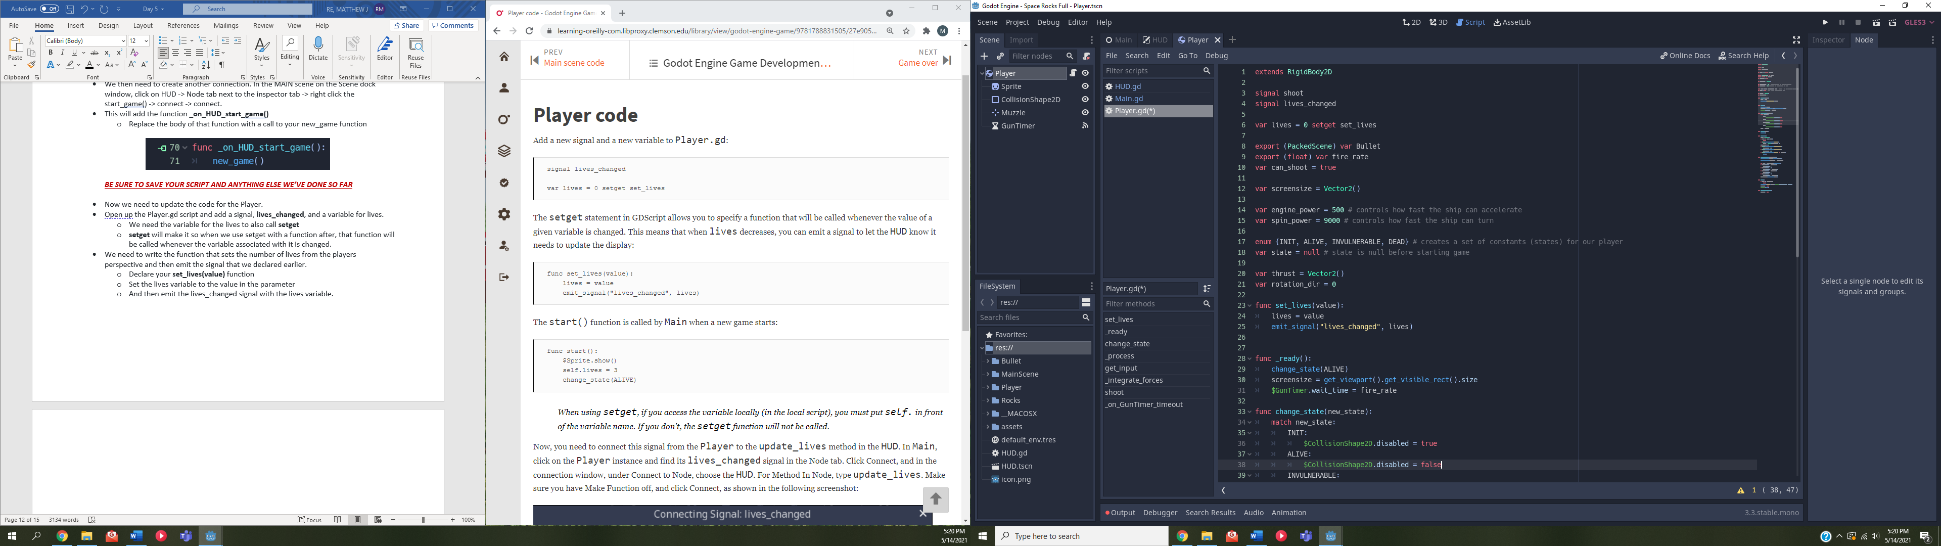



* Then we need to write the start function that we are trying to call in the main.
  + Declare your **start()** function.
  + Show your sprite
  + Set the lives to 3
  + And change the status to ALIVE

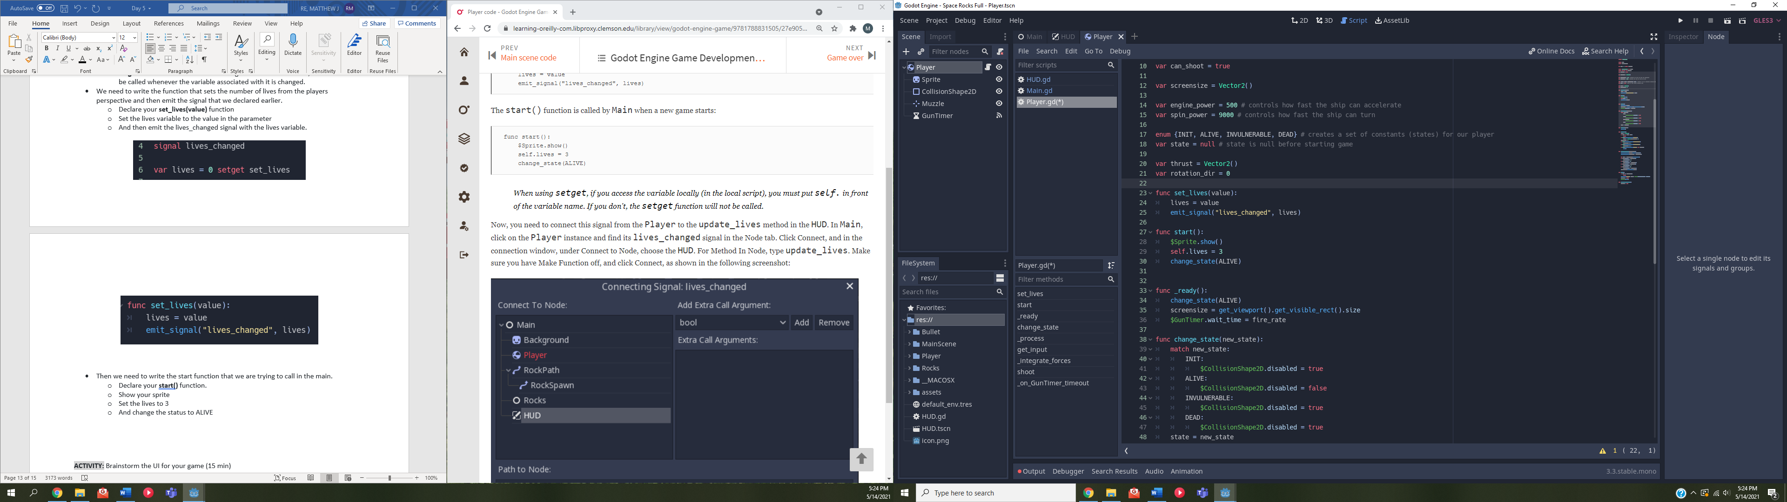

* We then need to connect the signal from the Player to the update_lives function in the HUD.
  + In the MAIN scene, click on Player -> Node tab -> lives_changed() -> right click -> connect… -> Click HUD in the window that pops up -> change the receiver method to “update_lives” -> connect.
  + This creates a connection to the update lives function in the HUD script.

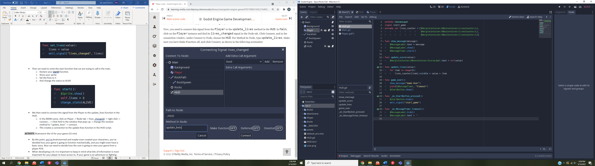

* Take a swing at your game!
  + By now, we have the start button working and the wave counter working. Play through a level and notice the number of rocks that spawn at each new level.
  + We aren’t done yet, though. We still need to have the ship detect when it has been hit by a rock, not to mention the score we’ll do later.
* Let’s work on the game overs.
  + Open up the player in the scene tab.
  + Add a timer node.
    - Rename the timer to InvulnerabilityTimer
  + Set the InvulnerabilityTimer to have a wait time of 2 and turn on One Shot.
  + Now, we need to add some code to the player script.
  + Open up Player.gd and add a **dead** signal.
  + Before we connect that signal to something, we need to add a few things to the change_state function.
  + We need to add some transparency states to each state. We can do this by adding **$Sprite.modulate.a** and setting it to either 0.5 or 1. Where 0.5 is semi-transparent and 1 is solid.
  + We want the init and invulnerable states to be semi-transparent, while the alive state should be solid.
  + Then, for the dead state, we need to disable the collision, hide the sprite, stop the movement of the sprite, and emit a dead signal.

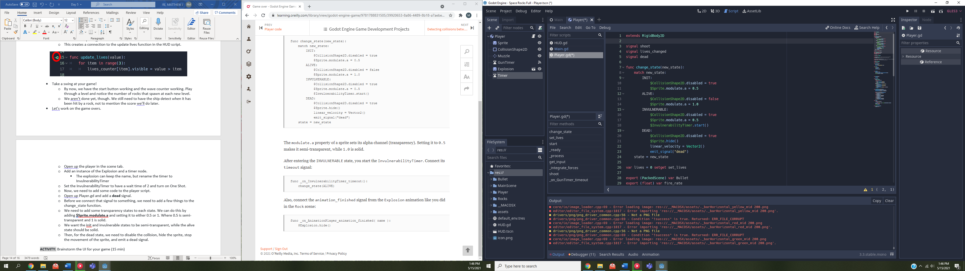

* Now, we need to do the connection.
  + Click on the InvulnerabilityTimer in the Scene window and -> node tab -> right click timeout() -> connect… -> connect.
    - This will create an **_on_InvulnerabilityTimer_timeout()** function. In the body of that function, remove the **pass** call and instead call you change_state function to change the state to ALIVE

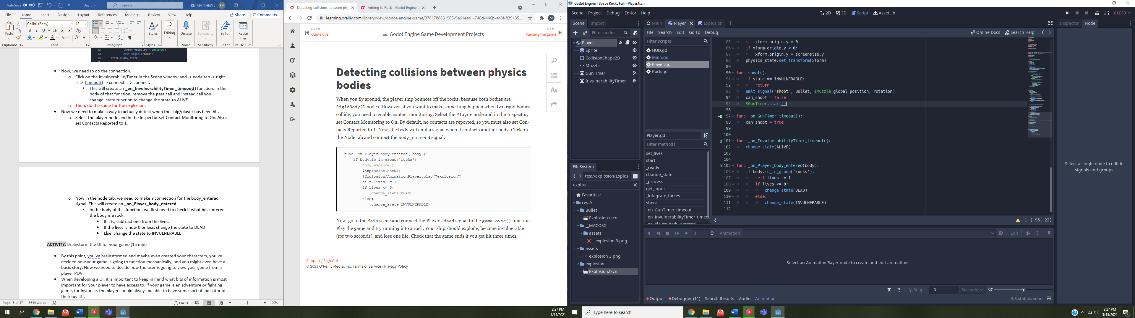

* Now we need to make a way to actually detect when the ship/player has been hit.
  + Select the player node and in the inspector set Contact Monitoring to On. Also, set Contacts Reported to 1.
  + Now in the node tab, we need to make a connection for the body_entered signal. **Be sure to click on player in the dialogue box**. This will create an **_on_Player_body_entered**.
    - In the body of this function, we first need to check if what has entered the body is a rock.
      * If it is, subtract one from the lives.
      * If the lives is now 0 or less, change the state to DEAD
      * Else, change the state to INVULNERABLE



* Now all we need to do for this is make a connection to the game_over function.
  + Go back into the main scene -> click on Player -> node tab -> dead() -> connect… -> change **_on_Player_dead** to **game_over.**
  + then in the created game_over function, we need to set playing to false and call the HUD’s game_over function

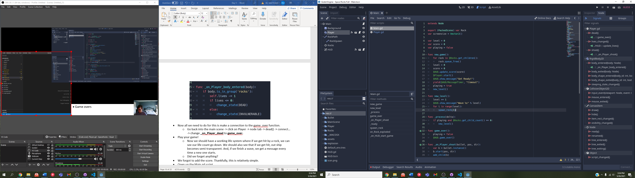

* Play your game!
  + Now we should have a working life system where if we get hit by a rock, we can see our life count go down. We should also see that if we get hit, out ship becomes semi-transparent. And, if we finish a wave, we get a message every time a new one starts.
  + Did we forget anything?
* We forgot to add the score. Thankfully, this is relatively simple.
* Open up the Main.gd script.
  + Do we have any functions already that detect when a rock has been destroyed?
  + We have the **on_Rock_exploded()** function
    - At the top of that function, lets add a line that takes the size of the rock we just destroyed, multiplies it by 10, and stores it (additively) in our score variable.
    - Then, all we need to do is call the HUDs **update_score** function and pass in the new score.

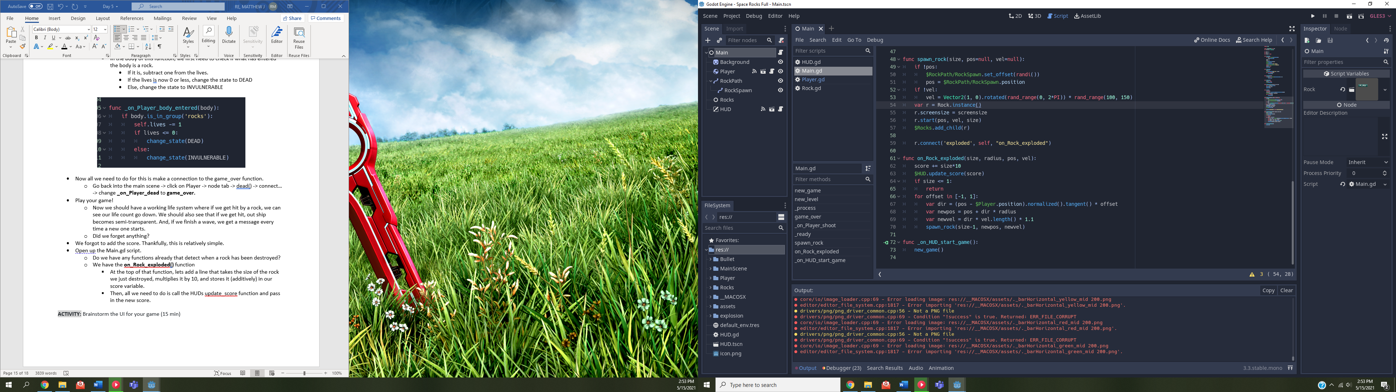

* Now if we play our game, we should have everything we set out to do.
* We’re going to add one more things a s a sort of finish touch.
* Right now there is no sound, so let’s add some audio to shooting the blaster.
  + Search for laser in the File System dock tab and notice the synthetic_laser.ogg file.
  + Ensure that loop is not checked On (so make sure it’s off) and that the Loop offset is 0.
  + Then we need to open up the Player Scene in the Scene dock tab
  + Add an AudioStreamPlayer to the player and rename it to BlasterSound.
  + Drag the synthetic_laser.ogg file to the Stream field In the inspector
  + Open up the Player.gd script and add a call to **play()** the BlasterSound in the **shoot()** function.

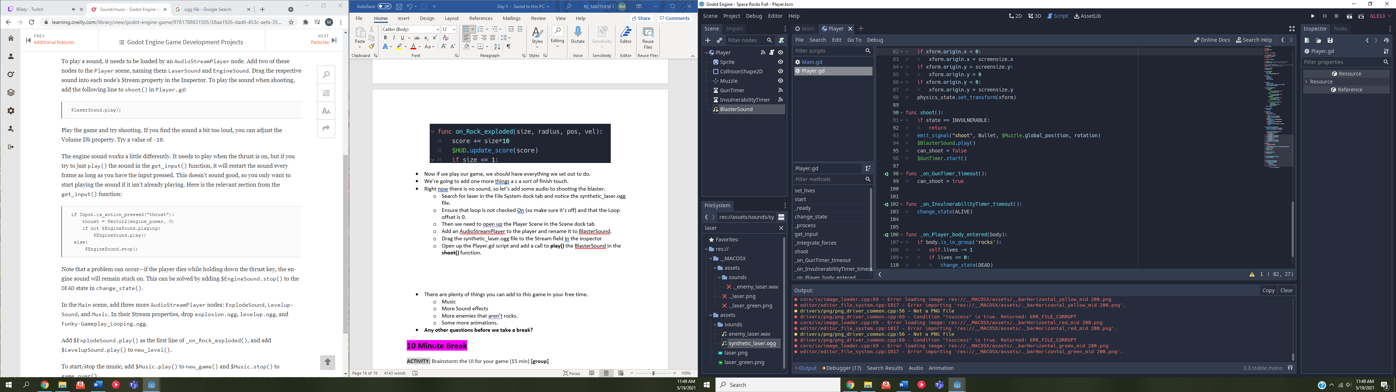

* Feel free to adjust the volume in the inspector.
* You can also add several different sound effects in your own free time.
  + Exploding an asteroid
  + An asteroid hitting the player
  + Moving to a new wave
  + Etc.
* There’s nothing else for this tutorial, but I encourage you to continue playing and adding to your game.
* There are plenty of things you can add to this game in your free time.
  + Music
  + More Sound effects
  + More enemies that aren’t rocks.
  + Some more animations.
  + Extra health power ups
* **Any other questions before we take a break?**

**10 Minute Break**

**ACTIVITY:** Brainstorm the UI for your game (15 min) **[group]**

* By this point, you’ve brainstormed and maybe even created your characters, you’ve decided how your game is going to function mechanically, and you might even have a basic story. Now we need to decide how the user is going to view your game from a player POV.
* When developing a UI, it is important to keep in mind what bits of information is most important for your player to have access to. If your game is an adventure or fighting game, for instance, the player should always be able to have some sort of indicator of their health.
* Create a list of all the key elements you want to put in your UI. While developing this list, assign a “Priority value” to each item. Back to the adventure/fighting game example, health might take a priority level higher than a map (It doesn’t have to, though!)

**INSTRUCTION**: What is prototyping? (approximately 10 minutes) **[camp]**

* Game prototyping is an important component in the game development process. This involves creating a method to test the concept of the game, to see if the idea of the video game can be put into practice before investing too much money and time in the project. (<https://starloopstudios.com/rapid-game-prototyping-why-is-it-important-in-game-development/#:~:text=Game%20prototyping%20is%20an%20important,and%20time%20in%20the%20project>.)
* Discuss why it is important we try to prototype games before development starts. (<https://www.uxpin.com/studio/blog/paper-prototyping-the-practical-beginners-guide/>)
  + Rapid iteration
  + Inexpensive
  + Increased creativity
  + Less of an up-front learning curve
  + Etc.
* Different ways to prototype:
  + Paper
  + Digital
  + Native
  + Any others or ‘subdivisions’ of the above methods (like sticky notes)?

**INSTRUCTION:** Summarize with a prototype video (7.5 minutes) **[camp]**

* <https://www.youtube.com/watch?v=JMjozqJS44M>

**ACTIVITY:** Prototype the UI for your game (50 min) **[individual -> within group]**

* Now, we’ll use the same idea of paper prototyping to make prototypes of our UI.
* Use paper, pencil, markers, etc. and the list you created a few minutes ago to begin making your game’s UI.
* While designing the prototype, take notes of the process for use in developing the UI in GoDot. Here are some things that might be worth writing down:
  + What was the priority (or order) of each created element?
  + Which elements were simple in theory, but more complicated to put on paper?
  + Is there anything we didn’t expect to need, but ended up needing anyway (such as more assets or more components of each element)
* When you’re finished. Take some time share your prototype with the group and discuss the notes you took.
* Everyone in the group should have a prototype. Discuss which elements you like from everyone’s prototype.
  + Keep in mind you don't have to use every element from *your* prototype. The purpose of having everyone create one is so that we can take the strongest elements from each one and use it to fix some gaps in your own. The end goal is to have a combination of everyone’s best work so that our final prototype is the best it can be.
* Discuss which elements from who’s prototype you could consider adding to your game.

**INSTRUCTION**: Ask if there are any final questions for the day before bringing the day to a close